**L1 Ops Guide**

**Operations Guide for L1 24x7**

In the operations guide you will find the below information in detail to start with L1 Montioring & Incident Management.

You will find

Information how to do your daily work

* + L1 task list
  + SLA times
  + Process flow overview
  + what do do for EU landscape
  + what if: SPC is down
  + Contacts
  + Product list & recomended actions list  for which we are responsible
  + Reporting needed: Shift report

Information for one time activities

* + Access :   
    HCP-Access: SPC, HCP Tool, OS , WTS, BCP, Global Management Portal (GMP) & Secure ID  
    HCI/FSN-Access: SPC,OS, WTS, BCP, Account Level Access,Tools-Eclipse  
    HCI-DS Access : SPC, OS, BCP, WTS, Account Level Access, NSQ Access
  + Cockpit & Landscape Details  
    HCP, HCI/FSN and HCI-DS Landscape details.
  + Service Provider Cockpit Handling
  + SAP Offshore Portal Link

**Operation Guide Link**

**HCP         :  \\dwdf213\technology\40_Public\Projects\CloudEngineering\30_CE_Team_Infos\2_Knowledge\HCPOperationsGuide.pdf**

**HCI-FSN  : \\dwdf213\technology\40_Public\Projects\CloudEngineering\30_CE_Team_Infos\2_Knowledge\HCI-FSNOperationsGuide.pdf**

**HCI-DS    :****\\dwdf213\technology\40_Public\Projects\CloudEngineering\30_CE_Team_Infos\2_Knowledge\HCI-DSODOperationsGuide.pdf**

**SCI          : \\dwdf213\technology\40_Public\Projects\CloudEngineering\30_CE_Team_Infos\2_Knowledge\SCI-OperationsGuide.pdf**

Note: Since L1 do not have access to above folder.

L1 Team can access from the following link

**\\INBLR102.blrl.sap.corp\sapall\TD_ECF\03_Teams\HCP\OperationsGuide**

**Supported Landscapes**

 L1 Team does 24x7 monitoring of incidents on the following landscapes:

| **HCP** | **HCIHCI** | **FSN** |
| --- | --- | --- |
| All Factory xx landscapes  Trial landscape  Prod landscape  Canary Landscape  Vlab landscape - only used for Knowledge transfer - not monitored (no productive customer landscape)   * Priorities – incidents are created inside SPC by JPaaS Monitoring Infrastructure with the following priorities for different landscapes:         Factory  – prio 1        Trial & Prod – prio 2        Vlab – prio 3 | FactoryEU1  FactoryUS1  FactoryAP1  FactoryCN1  FactoryJP1 | FactoryEU1  FactoryUS1  *[US1 Disaster Recovery for EU1]* |

**Supported Products**

We support products HCP, HCI, FSN,HCI-DS, Cloud Portal - see most current details in:  [Service Catalog](https://documents.wdf.sap.corp/share/page/site/cloud-engineering/document-details?nodeRef=workspace://SpacesStore/b988ae57-1a3b-47e3-a9f0-c514b67b8a76) .    More details on alerts covered at 1st September 2015 see below.

**System Monitoring & Incident Management Process:**

**Process Flow**

**HCP:**

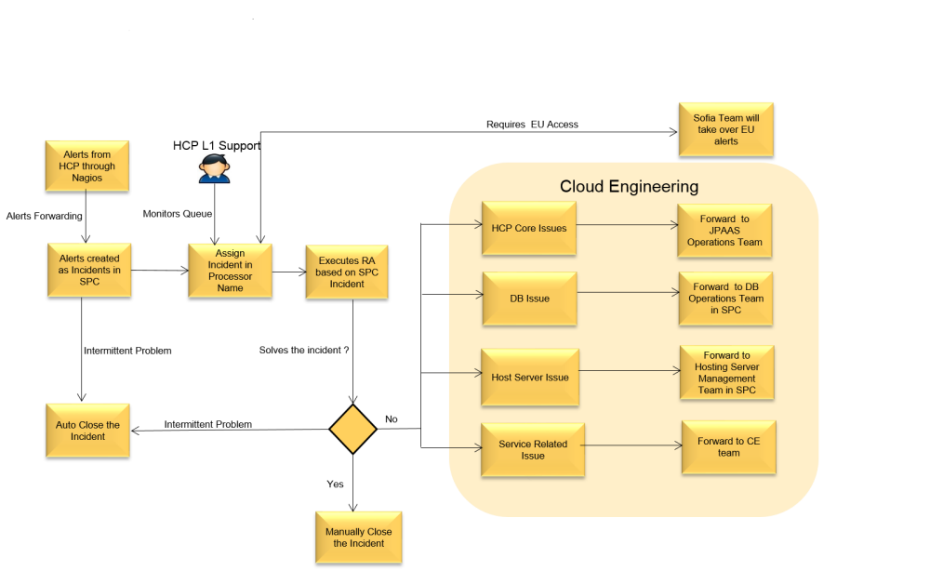

**HCI/FSN**

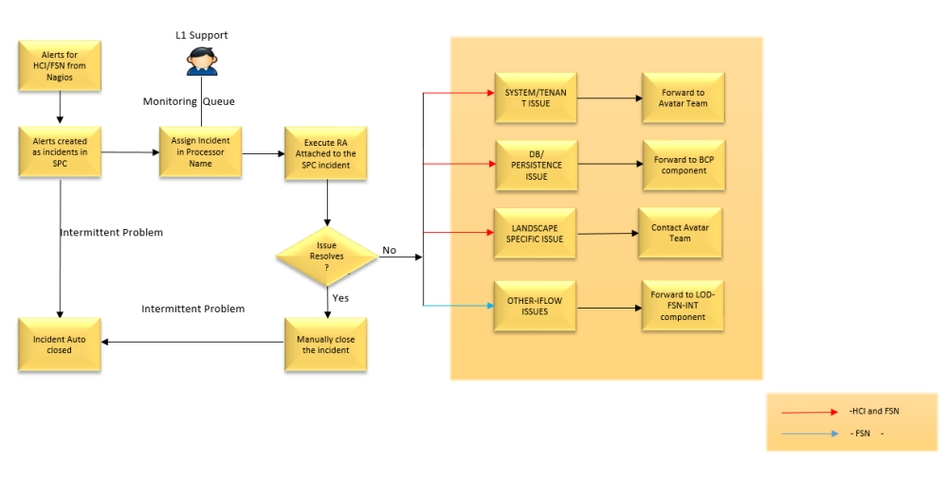

**SLA (Service Level Agreement) Times for Ticket Priority**

| **Landscape** | **IRT** | **MPT-Immediate** | **MPT -Urgent** |
| --- | --- | --- | --- |
| PROD | 15 min | 1 hr | 3 hr |
| Factory | 15 min | 1 hr | 3 hr |
| Trial | 15 min | 1 hr | 3 hr |

**How to Subscribe for Alerts in SPC via Mail ?**

(Disclaimer: So far the time delay in SPC and Mail is approx ~ 1minute )

1. Go to "Monitoring" in Top Level Navigation
2. Go to "Subscriptions"
3. Click on "New" Button
4. Enter the details as shown below(enter you email address, Queue and Priorities as shown in image)  
   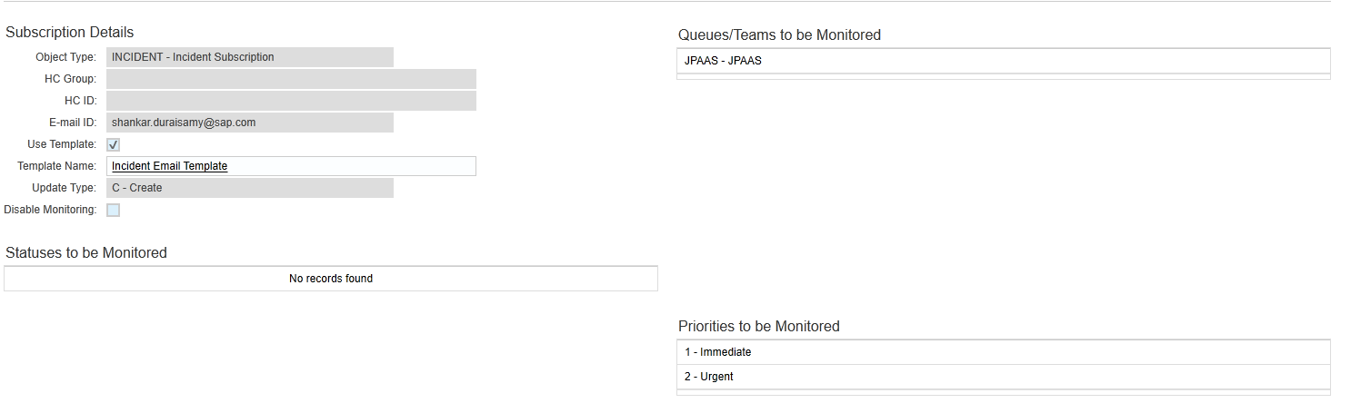
5. Now you will get the SPC incidents created as alerts in your inbox.

**Alerts triggered from Landscapes under EU Data Privacy Regulations**

For the Alerts triggered in SPC for EU Landscape forward the incidents to DL Saas Cloud EU Ops DBHCIHCP (External)  
Currently this DL will take care of L1 as well as DB OPS for Factory EU landscapes. So the L1 team Bangalore will forward  all the factory alerts to this above DL till the transition is done.

**What to do if SPC is down?**

1. Monitoring Tools that can be used for the Core Services. Site24x7   (see [Site24x7](https://wiki.wdf.sap.corp/wiki/display/EngSrv/70+CE+Team+Knowledge#id-70CETeamKnowledge-Site24x7) for access)
2. Services that can be monitored
   1. Account Cockpit - This means that the entire HCP is not accessible --> Inform CE on Duty
   2. CIS Service Availability - Commercial Infrastructure Services is down --> Follow the Service Downtime Process --> Raise NGPBUG for CIS Team and inform CE on Duty
   3. Cloud Security Authorization API - Authorizations Services are down --> Follow the Service Downtime Process --> Raise NGPBUG on Cloud Security and inform CE on Duty
   4. Cloud Security OAuth AS - OAuth Services are down --> Follow the Service Downtime Process --> Raise NGPBUG on Cloud Security and inform CE on Duty
   5. Connectivity Service - Connectivity Services are down --> Follow the service downtime process --> Raise NGPBUG on Connectivity and inform CE on Duty
   6. Deploy API - Deploy services are down --> Follow the service downtime process --> Raise NGPBUG on Operations Team and inform CE on Duty
   7. Destination Configuration - Destination are down --> Follow the service downtime process --> Raise NGPBUG on Connectivity and inform CE on Duty
   8. Extensions Services - Extensions Services are down --> Follow the service the downtime process --> Raise NGPBUG on Extensions and inform CE on Duty

**Q&A on "Monitoring SPC and Alerting" Process**

Q: Which teams from HCP provide also 24x7 or at least 8x7 DevSupport  on weekends?    
A: HCP Ops Team and Persistency team (Hotline) see [https://wiki.wdf.sap.corp/wiki//x/_x4lSw](https://wiki.wdf.sap.corp/wiki/x/_x4lSw)  and Cloud Portal see [https://wiki.wdf.sap.corp/wiki//x/lbHOZg](https://wiki.wdf.sap.corp/wiki/x/lbHOZg)

Q: How do we ensure that we all know what is open, who works in which incident?  
A: In SPC it is clear who is processor; also in BCP and JIRA.

**Contacts from Other Teams**

See in [https://wiki.wdf.sap.corp/wiki//x/_aAvaw](https://wiki.wdf.sap.corp/wiki/x/_aAvaw)

**Transparency and Reporting from L1 24x7 Team**

**Shift Report mail by C-users after each shift**

**Template :**

Hi Team,

**HCP Status:**

**Note:**

IoT service update are done for FACTORY US1,US2,AP1,EU1.

**Alerts:**

**Open issues:**

No open issues.

**HCI/FSN Status:**

**Note:**

* + - * Multiple alerts in FACTORY landscape,  [OUTAGE-594](https://jtrack.wdf.sap.corp/browse/OUTAGE-594) [OUTAGE-595](https://jtrack.wdf.sap.corp/browse/OUTAGE-595) [NGPBUG-28955](https://jtrack.wdf.sap.corp/browse/NGPBUG-28955) (PFA)
      * Flapping  alerts in **FACTORYUS1** landscape - [OUTAGE-522](https://jtrack.wdf.sap.corp/browse/OUTAGE-522)/ [OUTAGE-540](https://jtrack.wdf.sap.corp/browse/OUTAGE-540)

**BCP Status:**

**Open issues:**

**Regards,**

<team member name>

**Owner: Sundar Weekly Report and Sync Meeting**

**Participants**: Andreas Juettner, Robert Kampfmann, Shankar, Sundar, Hristo Kostov

**Time**: Monday, 30 min

**Agenda:**

* + Report on Operations of the week:  #alerts in SPC raised, #completed automatically w/o activity from L1, #completed manually by L1 (after Recommended activity), #forwarded to L1 EU-DP,  #forwarded to L2 DBOps, #forwarded to CE team, #forwarded to SAP IT; #alerts still open   (also show history of last 4 weeks)
  + Report on adherence to our process controls (Initial reaction time, Maximum processing time) for all incidents in SPC;
  + Report on Continuous Improvement: Findings, Proposed activities; done activities
  + Outlook next week(s): any news, changes
  + Weekly Reporting <<https://documents.wdf.sap.corp/share/page/site/nwcloudsupport/documentlibrary?file=CW25_HCP_Report.pptx#filter=path%7C%2FSPC+Reports%2F2015&page=2>>

**Recommened Actions (executed by the L1 24x7 team)**

**Note: (National Football League (NFL) alerting & monitoring stays with SaaS Cloud -  [https://wiki.wdf.sap.corp/wiki//x/algdVg](https://wiki.wdf.sap.corp/wiki/x/algdVg)**

                 Alerts from the below hosts should be forwarded to V.N, Mohammed Razal (I314156)

|  |  |  |
| --- | --- | --- |
| **12** | **SID** | **Host** |
| NFL – ASHBURN | B0S | vadbb0s.ash.od.sap.[biz:30215](http://biz:30215/) |
| NFL – ASHBURN | B0T | vadbb0t.ash.od.sap.[biz:30215](http://biz:30215/) |
| NFL – ASHBURN | B0U | vadbb0u.ash.od.sap.[biz:30215](http://biz:30215/) |
| NFL – ASHBURN | B0V | vadbb0v.ash.od.sap.[biz:30215](http://biz:30215/) |
| NFL – ASHBURN | B0W | vadbb0w.ash.od.sap.[biz:30215](http://biz:30215/) |
| NFL – ASHBURN | B0X | vadbb0x.ash.od.sap.[biz:30215](http://biz:30215/) |
| NFL – ASHBURN | B0Z | vadbb0z.ash.od.sap.[biz:30215](http://biz:30215/) |
| NFL – ASHBURN | B11 | vadbb11.ash.od.sap.[biz:30215](http://biz:30215/) |
| NFL – ASHBURN | B12 | vadbb12.ash.od.sap.[biz:30215](http://biz:30215/) |
| NFL – ASHBURN | B14 | vadbb14.ash.od.sap.[biz:30215](http://biz:30215/) |
| NFL – ASHBURN | B15 | vadbb15.ash.od.sap.[biz:30215](http://biz:30215/) |
| NFL – ASHBURN | B17 | vadbb17.ash.od.sap.[biz:30215](http://biz:30215/) |
| NFL – ASHBURN | B18 | vadbb18.ash.od.sap.[biz:30215](http://biz:30215/) |

For more context, including information such as which alerts trigger certain RAs and the frequency of some alerts, please refer to:

\\dwdf213\technology\40_Public\Projects\CloudEngineering\30_CE_Team_Infos\2_Knowledge\Analysis_SPC_Incidents_&_RAs_for_JPaaS.xlsx

The current Recommended action you find always here <http://cmtools.byd.sap.corp:50000/RA/>.

For review and maintenance the RA are stored in Gitub: <https://github.wdf.sap.corp/CloudEngineering2016/cloudengineering/tree/master/RA>

The list below is taken from the spreadsheet linked above. It is accurate as of September 9, 2015.

**Recommened Actions Update process description (PROPOSAL)**

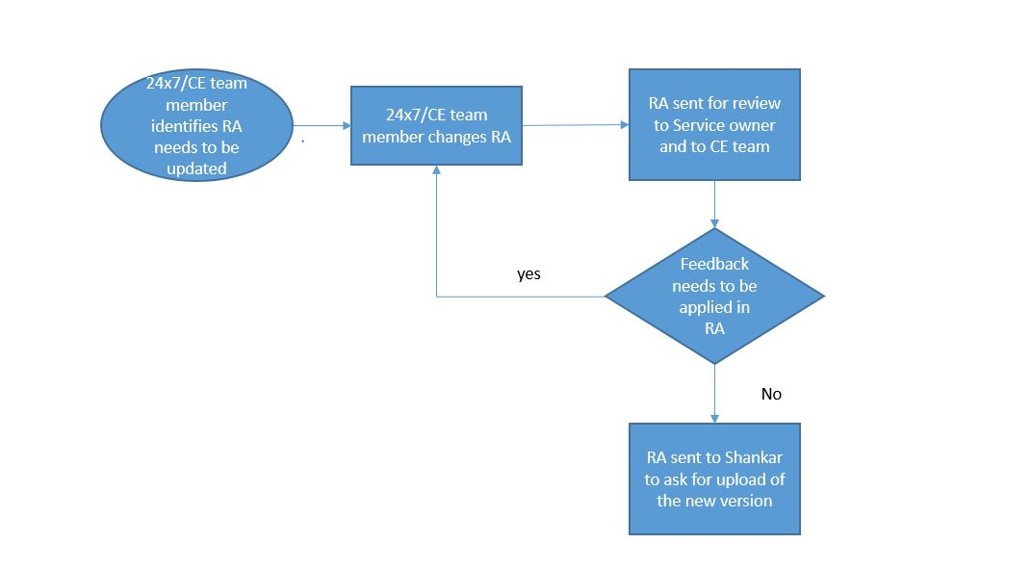

**Responsibilities of L1/L2 Team and Cloud Engineers and  Development Teams**

|  |  |  |  |  |
| --- | --- | --- | --- | --- |
| **Areas** | **L1 Ops Team** | **L2 / L3 DBOps Team** | **Cloud Engineers** | **Development Teams** |
| Monitoring and Alerting | •Track for alerts in SPC and in site24x7  •Execute the Recommended Actions (RA) within SLA’s | •Proactive Monitoring of DB services | •Proactive Monitoring of platform | •Proactive Monitoring of services |
| Incident Management | •Identify problems  •Raise incident in BCP or forward SPC incident to the DBOps team with appropriate debugging information | •Identify root causes of incidents (RCA)  •Fix Live Site incidents  •Incident Management including Customer Communication | •Fix Live site incidents  •Incident Management with DevTeams including Customer Communication | •Fix Live site incidents |

\\dwdf213\technology\40_Public\Projects\CloudEngineering\30_CE_Team_Infos\2_Handover_From_SaaS_Cloud_L1\Handover_Information_V01.xlsx